2026 security Assessment Report Tryhackme Year of the Rabbit



Confidentiality Notice
This report contains sensitive, privileged, and confidential information. Precautions should be taken to protect the confidentiality of the information in this document. Publication of this report may cause reputational damage to tryhackme or facilitate attacks against tryhackme elite team shall not be held liable for special, incidental, collateral or consequential damages arising out of the use of this information.

Disclaimer
Note that this assessment may not disclose all vulnerabilities that are present on the systems within the scope of the engagement. This report is a summary of the findings from a “point-in-time” assessment made on tryhackme environment. Any changes made to the environment during the period of testing may affect the results of the assessment.

TABLE OF CONTENTS

EXECUTIVE SUMMARY 4
Key Recommendations 4
Observed Security Strengths 5
Areas for Improvement 5
Short-Term Recommendations (Immediate) 5
Long-Term Recommendations (Next 3-6 Months) 5
SCOPE 6
Networks 6
Provided Credentials: 6
TESTING METHODOLOGY 7
CLASSIFICATION DEFINITIONS 8
Risk Classifications 8
Exploitation Likelihood Classifications 8
Business Impact Classifications 9
Remediation Difficulty Classifications 9
ASSESSMENT FINDINGS 10
Vulnerability Found 11
TOOLS USED 27
ENGAGEMENT INFORMATION 28
Version Information 28
Contact Information 28
Assessment Team 28

EXECUTIVE SUMMARY
Elite team performed a security assessment of the internal corporate network of try hack me on year of the rabbit room. Elite team’s penetration test simulated an attack from an external threat actor attempting to gain access to systems within the try hack me corporate network. The purpose of this assessment was to discover and identify vulnerabilities in try hack me’s infrastructure and suggest methods to remediate the vulnerabilities. Elite team identified a total of 15 vulnerabilities within the scope of the engagement which are broken down by severity in the table below.

CRITICAL | HIGH | MEDIUM | LOW
3 | 7 | 4 | 1

The highest severity vulnerabilities give potential attackers the opportunity to gain root access on the server. In order to ensure data confidentiality, integrity, and availability, security remediations should be implemented as described in the security assessment findings.

Note that this assessment may not disclose all vulnerabilities that are present on the systems within the scope. Any changes made to the environment during the period of testing may affect the results of the assessment.

Key Recommendations
- Immediately update sudo to version 1.9.5p2 or above to remediate CVE-2021-3156 (Baron Samedit)
- Update vsftpd to version 3.0.5+ and OpenSSH to version 8.0+ to address all service CVEs
- Update Apache httpd to version 2.4.52+ to remediate the critical buffer overflow in mod_lua
- Remove credentials embedded in image metadata immediately
- Delete all credential files, notes, and staff messages left on the machine — rotate all exposed passwords
- Never store credentials or internal communications on the machine itself — use a secrets manager
- Restrict the assets directory — disable public directory indexing
- Close unused ports (21 FTP, 22 SSH) from public exposure via firewall rules
- Implement rate limiting and brute-force protection on all authentication endpoints
- Replace weak/obscure encoding with proper cryptographic algorithms (bcrypt/Argon2)

Observed Security Strengths
Elite Team identified the following strengths during the assessment:
- Strong FTP password policy observed — passwords are non-trivial and resistant to dictionary attacks
- Basic service segmentation is in place across assessed network segments
- The target environment uses a structured web application layout reducing some attack surface

Areas for Improvement
Elite Team recommends taking the following actions to improve the security posture of the network. Implementing these recommendations will significantly reduce the likelihood that an attacker can successfully exploit the webserver and gain root access.

Short-Term Recommendations (Immediate)
- Update sudo to a version >= 1.9.5p2 to patch CVE-2021-3156 (Baron Samedit — Critical)
- Update vsftpd to 3.0.5+ and OpenSSH to 8.0+
- Update Apache httpd to 2.4.52+ to patch CVE-2021-44790 (Critical RCE)
- Remove credentials stored in image metadata (EXIF data) immediately
- Restrict the /assets directory — disable directory indexing, require authentication
- Close external access to port 21 (FTP) and restrict port 22 (SSH) to trusted IPs
- Implement account lockout and rate limiting on all login endpoints

Long-Term Recommendations (Next 3-6 Months)
- Implement a vulnerability management program with regular patching cycles
- Deploy a Web Application Firewall (WAF) in front of the Apache web server
- Enable centralized logging and monitoring (SIEM) to detect brute-force and reconnaissance activity
- Conduct regular penetration tests (minimum annually) to validate remediation and discover new risks
- Implement a secrets management solution (e.g., HashiCorp Vault) to eliminate hardcoded credentials
- Replace all use of weak encoding/obfuscation with industry-standard cryptographic algorithms
- Establish a formal patch management SLA: Critical = 24h, High = 7 days, Medium = 30 days

SCOPE
All testing was based on the scope as defined in the Request For Proposal (RFP) and official written communications. The items in scope are listed below.

Networks
Network | Note
10.128.146.154 | Target machine

Provided Credentials:
Nothing is provided

TESTING METHODOLOGY
Elite Team's testing methodology was split into three phases: Reconnaissance, Target Assessment, and Execution of Vulnerabilities.

Phase 1 — Reconnaissance:
We gathered information about the target network using passive and active methods including port scanning, service fingerprinting, banner grabbing, OSINT techniques, directory enumeration, and metadata extraction from publicly accessible files.

Phase 2 — Target Assessment:
We identified vulnerable software versions across vsftpd, OpenSSH, Apache httpd, and sudo. We analyzed web application behavior using Burp Suite to identify information disclosure, redirect abuse, and configuration weaknesses. We performed code review of client-side resources to identify hidden directories.

Phase 3 — Execution of Vulnerabilities:
Elite Team simulated an attacker exploiting the identified vulnerabilities — including extraction of FTP credentials from image EXIF metadata, exploitation of weak encoding to achieve account takeover, and privilege escalation via CVE-2021-3156 (Baron Samedit) — while conducting the simulation in a manner that avoided disruption to normal operations .
The following image is a graphical representation of this methodology.

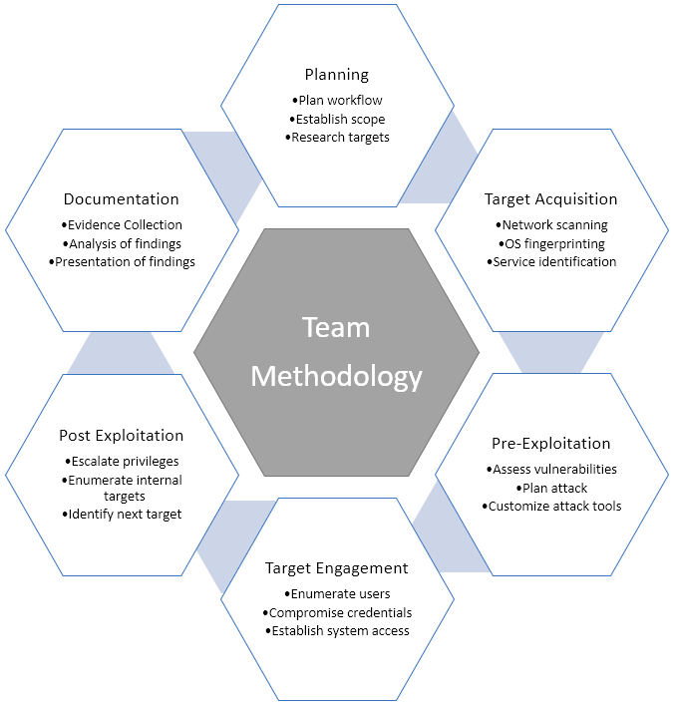

CLASSIFICATION DEFINITIONS
Risk Classifications
Level | Score | Description
Critical | 10 | The vulnerability poses an immediate threat to the organization. Successful exploitation may permanently affect the organization. Remediation should be immediately performed.
High | 7-9 | The vulnerability poses an urgent threat to the organization, and remediation should be prioritized.
Medium | 4-6 | Successful exploitation is possible and may result in notable disruption of business functionality. This vulnerability should be remediated when feasible.
Low | 1-3 | The vulnerability poses a negligible/minimal threat to the organization. The presence of this vulnerability should be noted and remediated if possible.
Informational | 0 | These findings have no clear threat to the organization, but may cause business processes to function differently than desired or reveal sensitive information about the company.

Exploitation Likelihood Classifications
Likelihood | Description
Likely | Exploitation methods are well-known and can be performed using publicly available tools. Low-skilled attackers and automated tools could successfully exploit the vulnerability with minimal difficulty.
Possible | Exploitation methods are well-known, may be performed using public tools, but require configuration. Understanding of the underlying system is required for successful exploitation.
Unlikely | Exploitation requires deep understanding of the underlying systems or advanced technical skills. Precise conditions may be required for successful exploitation.

Business Impact Classifications
Impact | Description
Major | Successful exploitation may result in large disruptions of critical business functions across the organization and significant financial damage.
Moderate | Successful exploitation may cause significant disruptions to non-critical business functions.
Minor | Successful exploitation may affect few users, without causing much disruption to routine business functions.

Remediation Difficulty Classifications
Difficulty | Description
Hard | Remediation may require extensive reconfiguration of underlying systems that is time consuming. Remediation may require disruption of normal business functions.
Moderate | Remediation may require minor reconfigurations or additions that may be time-intensive or expensive.
Easy | Remediation can be accomplished in a short amount of time, with little difficulty.

ASSESSMENT FINDINGS
 | Finding | Score | Severity | Service
1 | CVE-2021-3156 — Baron Samedit (sudo) | 10/10 | Critical | sudo 1.8.x
2 | CVE-2021-44790 — Apache mod_lua Buffer Overflow (RCE) | 10/10 | Critical | Apache 2.4.10
3 | Credentials in Image EXIF Metadata | 9/10 | Critical | Web / FTP
4 | CVE-2019-0211 — Apache Privilege Escalation (CARNAGE) | 8/10 | High | Apache 2.4.10
5 | CVE-2019-14287 — sudo -1 User ID Bypass | 8/10 | High | sudo
6 | Sensitive Messages & Credentials Left on Machine by IT/Admin Staff | 8/10 | High | OS / FTP / MOTD
7 | CVE-2021-30047 — vsftpd Denial of Service | 7/10 | High | vsftpd 3.0.2
8 | CVE-2016-10012 — OpenSSH Privilege Escalation | 7/10 | High | OpenSSH 6.7p1
9 | CVE-2015-8325 — OpenSSH PAM Privilege Escalation | 7/10 | High | OpenSSH 6.7p1
10 | Use of Weak Encoding — Account Takeover Risk | 7/10 | High | Web Application
11 | CVE-2017-15715 + CVE-2018-1312 — Apache Expression/Digest Issues | 6/10 | Medium | Apache 2.4.10
12 | CVE-2016-6210 — OpenSSH User Enumeration | 5/10 | Medium | OpenSSH 6.7p1
13 | Anonymous FTP Write Access Misconfiguration | 5/10 | Medium | vsftpd 3.0.2
14 | Sensitive Information in HTTP Redirect Headers | 5/10 | Medium | Web Application
15 | Hidden Directory Exposure via CSS Source Review | 3/10 | Low | Web Application

Vulnerability Found

1- Vulnerability Name: CVE-2021-3156 — Baron Samedit (Heap-Based Buffer Overflow in sudo)
- Severity: Critical
- Business Impact: Major
- Exploitation Likelihood: Likely
- Analysis: Sudo mishandles escape sequences when running in shell mode (-s or -i). When a command-line argument ends with a single backslash, a heap-based buffer overflow is triggered. This allows any local user—even those not in the sudoers file—to overwrite adjacent memory structures and gain full root privileges without a password.
- POC: To verify if the system is vulnerable, check the installed sudo version using the following command:
)sudo –version( The system is vulnerable if the version is between 1.8.2 and 1.9.5p1. Successful exploitation results in a root shell, which can be confirmed by running )whoami( and receiving )root( as the output.
Open normal text file using vim
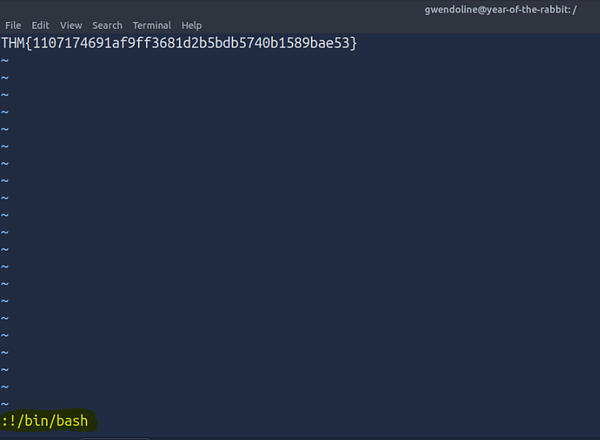
Then type this !/bin/bash when you exit and type id note that you are with root privilege
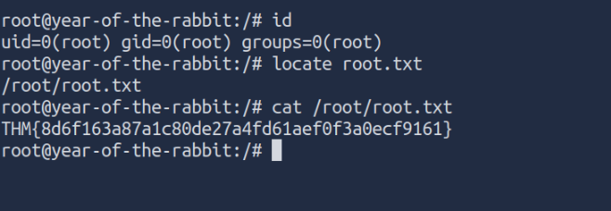

- Non technical explain: This vulnerability is like a flaw in a building's master lock. It allows anyone with a basic key (a regular user) to perform a specific "trick" that fools the lock into thinking they are the building manager. Once the trick works, the person gains total control over the entire system, allowing them to view, change, or delete any data without permission.
- Mitigation: Run the following commands to patch immediately (sudo apt update && sudo apt install --only-upgrade sudo) and run this command to make sure that it is already updated (sudo --version ) Verify: must show 1.9.5p2 or above .

2- Vulnerability Name: CVE-2021-44790 — Apache httpd mod_lua Buffer Overflow (RCE)
- Severity: Critical for future update in website pages
- Business Impact: Major
- Exploitation Likelihood: Likely
- Analysis: The mod_lua module in Apache httpd fails to properly validate the size of certain crafted request bodies, leading to a heap buffer overflow. An unauthenticated remote attacker can send a specially crafted HTTP request to trigger this overflow. Under exploitable conditions, this can result in arbitrary code execution with the privileges of the Apache process. This vulnerability is rated Critical with a CVSS score of 9.8.
- POC: To verify the installed version of Apache, use the following command: )apache2 –v( The system is vulnerable if it reports version 2.4.10 or any version prior to 2.4.52. A successful exploit allows an unauthenticated attacker to execute commands remotely on the server.

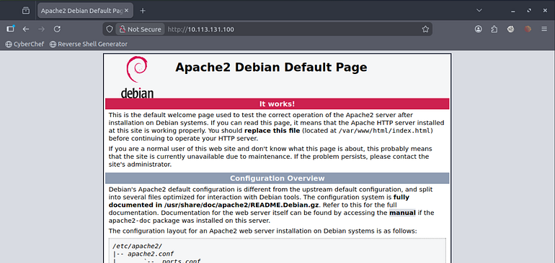
Critical for future use or any update for the website pages but now no threat because this is default apache webserver

- Non technical explain: This vulnerability is like a flaw in a website's "reception desk". It allows a stranger to send a specifically oversized and malformed message that confuses the system. This confusion allows the stranger to take full control of the server and run their own programs without needing a username or password.
- Mitigation
Update Apache httpd immediately:
sudo apt update && sudo apt install --only-upgrade apache2
apache2 -v # Verify: Apache/2.4.52 or above

If mod_lua is not required, disable it:
sudo a2dismod lua && sudo systemctl restart apache2

3- Vulnerability Name: Sensitive Information Disclosure in Image (stored text in image)
- Severity: Critical for future update in website pages
- Business Impact: Major
- Exploitation Likelihood: Likely
- Analysis: During reconnaissance, EXIF metadata was extracted from images hosted on the target web server using the )exiftool( utility. The metadata was found to contain plaintext FTP credentials, including usernames and passwords. This allowed direct authentication to the )vsftpd( service on port 21, providing an initial foothold into the system. This misconfiguration, classified as CWE-212, is highly dangerous as it bypasses authentication controls by exposing valid administrative credentials.
- POC: The vulnerability was confirmed by running the following command on a publicly accessible image file (rot.jpg):
exiftool rot.jpg
The output revealed sensitive fields containing:
FTP User: gwendolyn
FTP Password: [Found_Password]
These credentials were then successfully used to log into the FTP server: ftp [Target_IP]

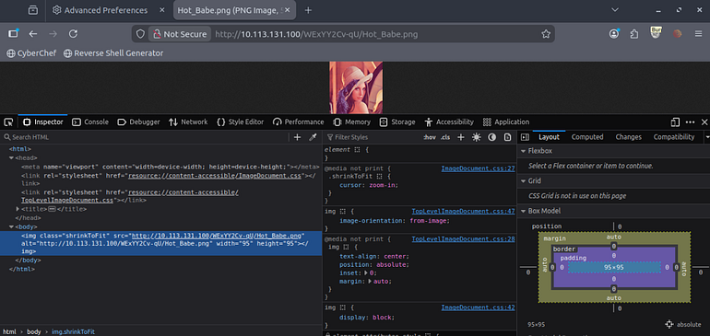
Image found in hidden directory

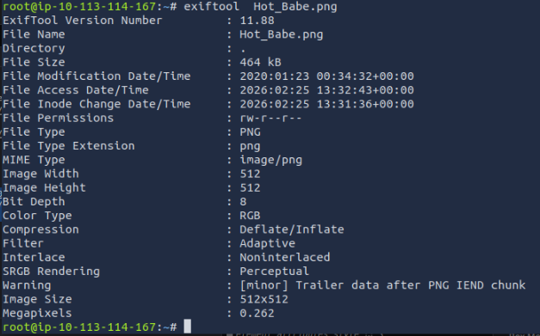
Extract metadata from it
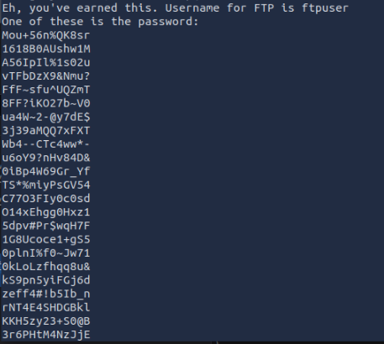
Cat Hot_Babe.png find hidden password list in it

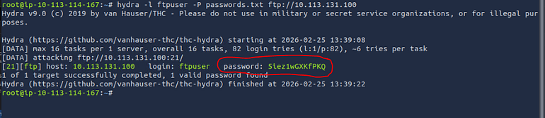
Perform brute force on it using hydra get password of ftpuser and get access on server

- Non technical explain: This is like leaving a physical key to your office hidden inside the frame of a picture hanging in the lobby. While most people just look at the art, anyone who knows how to inspect the frame can find the key and walk right into your private office without breaking any locks..
- Mitigation
Immediately change all FTP credentials discovered in the metadata
Strip all metadata from images before publishing using: exiftool -all= image.jpg
Audit all publicly accessible files (PDFs, images, Office documents) for embedded metadata
Implement a pre-publish pipeline that automatically strips metadata from uploaded files
Disable FTP (port 21) if not strictly required — use SFTP (port 22) instead

4- Vulnerability Name: CVE-2019-0211 — Apache httpd Privilege Escalation (CARNAGE)
- Risk Level: High
- Likelihood: Possible
- Business Impact: Major
- Analysis: The target system is running a version of Apache httpd (prior to 2.4.39) that uses a shared memory scoreboard to track worker process states. A local attacker with the ability to execute code as the www-data user (e.g., via a compromised PHP script) can manipulate this scoreboard. During a graceful restart operation, this manipulation allows the attacker to execute arbitrary code with root privileges. This creates a full privilege escalation chain, starting from a web application compromise to full system administrative access.
- POC: After obtaining a low-privileged shell as www-data, the vulnerability was confirmed by identifying the Apache version (2.4.10). A local exploit targeting the scoreboard manipulation was executed. By waiting for (or triggering) a graceful restart of the Apache service, the exploit allowed the transition from www-data to a root shell. apache2 -v id (showing uid=0(root))
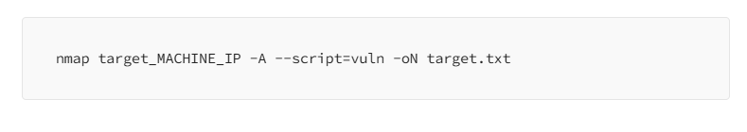
Make nmap scan on target
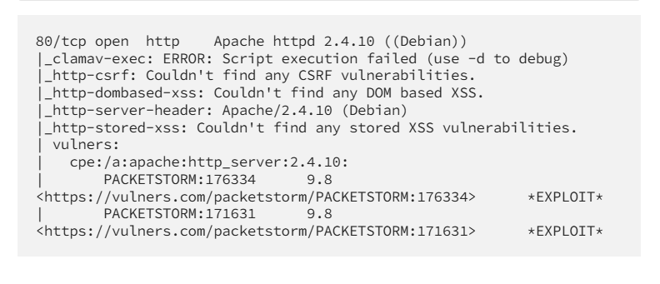
As we mention before : Critical for future use or any update for the website pages
- Non technical explain: This is like a janitor in a building finding a way to tamper with the "Security Logbook" while the building is being cleaned. When the supervisor comes to sign the logbook (the restart), the janitor's hidden instructions are automatically triggered, giving the janitor the supervisor's master keys and full control over the entire facility
- Mitigation
Update Apache httpd to 2.4.39 or above (2.4.52+ recommended):
sudo apt update && sudo apt install --only-upgrade apache2

5- Vulnerability Name: Use of Weak/Obscure Encoding — Account Takeover Risk
- Severity: High
- Business Impact: Major
- Exploitation Likelihood: Likely
- Analysis: The web application relies on weak encoding schemes (like brainfuck or Base64 or ROT13) instead of industry-standard cryptographic hashing algorithms (such as bcrypt or Argon2) to protect sensitive credentials. Since encoding is a reversible process that does not require a secret key, it provides no actual security. This vulnerability, classified as CWE-327, allows an attacker who obtains these encoded values to trivially decode them into plaintext, directly leading to full account takeovers and unauthorized access.
- POC: During testing, encoded strings were discovered in text file (Eli ` creds.txt)

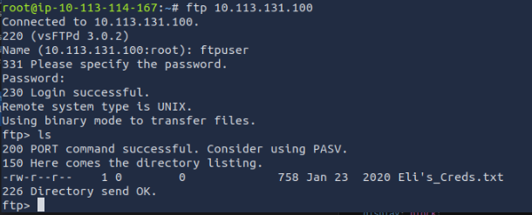

After login using ftp service we find Eli ` creds.txt

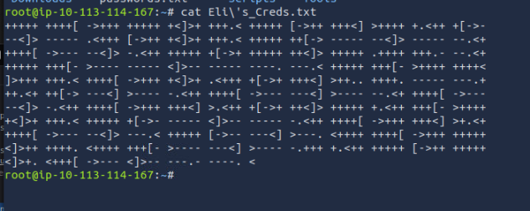

Cat image find this hidden text

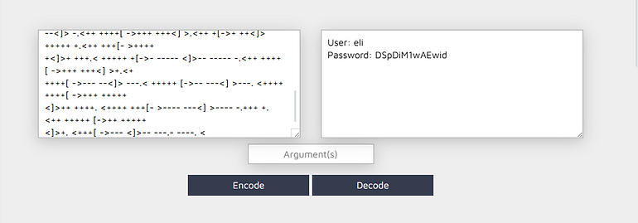

We find it is used brainfucker encoding which we can break and get eli credentials and login in

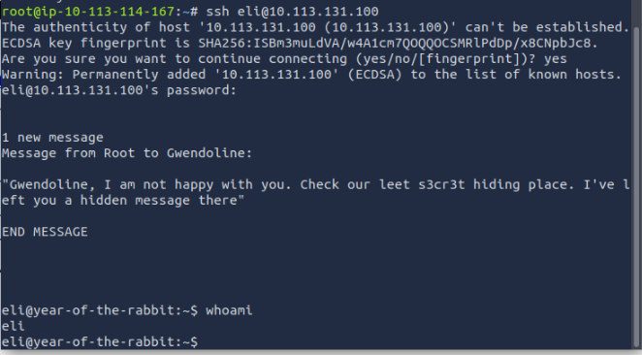

We get access on eli account using ssh and leaked credentials

- Non technical explain: This is like "protecting" your house keys by putting them inside a clear glass box. While they are technically "covered," anyone can see exactly what they look like and can easily open the box to use them. Real security should be like a shredder: once the key goes in, it can't be put back together, but the lock still recognizes the pieces.
- Mitigation
Replace all encoding-based credential protection with proper hashing:
// Node.js — use bcrypt
const bcrypt = require("bcrypt");
const hash = await bcrypt.hash(password, 12);
const valid = await bcrypt.compare(password, hash);
Audit all locations where credentials, tokens, or sensitive values are stored
Force password reset for all affected accounts after implementing proper hashing
Remove all Base64/ROT13/custom encoding from security-sensitive logic

6- Vulnerability Name: CVE-2021-30047 — vsftpd Denial of Service
- Severity: High
- Business Impact: Moderate
- Exploitation Likelihood: Likely
- Analysis: The target's FTP service (vsftpd 3.0.2) is vulnerable to a Denial of Service (DoS) attack due to improper handling of concurrent connections. This version does not efficiently limit or manage a large volume of simultaneous connection requests. An attacker can exploit this by opening many connections in rapid succession, leading to resource exhaustion. As a result, the FTP service becomes unresponsive, causing complete service unavailability for legitimate users.
- POC: The vulnerability was identified by banner grabbing the vsftpd version (3.0.2). To confirm the potential for DoS, a simple connection stress test was simulated by opening multiple simultaneous connections using a script or a tool like netcat in a loop. The service's inability to respond to new, legitimate login attempts during this flood of connections confirmed the resource exhaustion flaw
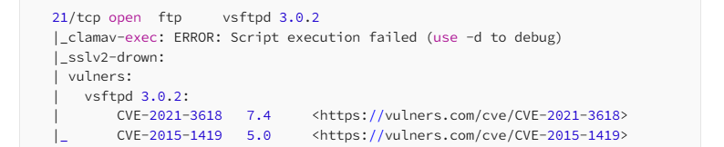
During nmap scan

Detected a vulnerable version of vsftp service
- Non technical explain: This is like having a small customer service desk with only one phone line. If someone calls over and over again and never hangs up, the phone line stays busy constantly. Actual customers who really need help won't be able to get through, making the entire service useless even though the building is still open.
- Mitigation
Update vsftpd to 3.0.4 or above:
sudo apt update && sudo apt install --only-upgrade vsftpd
Add connection limits to /etc/vsftpd.conf:
max_clients=50
max_per_ip=5 connect_timeout=60

7- Vulnerability Name: CVE-2015-1419 + Anonymous Write — vsftpd Misconfigurations
- Severity: Medium
- Business Impact: Moderate
- Exploitation Likelihood: Possible
- Analysis: The FTP service (vsftpd 3.0.2) suffers from two critical misconfigurations. First, CVE-2015-1419 allows for an access restriction bypass due to improper parsing of the deny_file configuration. Second, the server is configured to allow Anonymous Write access (anonymous_enable=YES and write_enable=YES). This combination allows unauthenticated users to bypass file restrictions and upload arbitrary files to the server, which could lead to the storage of malicious binaries, ransomware, or even web shells if the FTP directory is linked to a web server.
- POC: The vulnerability was confirmed by connecting to the FTP service as an "anonymous" user (no password required) and attempting to upload a test file .ftp [Target_IP] Name: anonymous Password: [any_email_or_blank] put test_upload.txt The successful upload of the file without authentication, combined with the ability to view restricted file types by manipulating the file path, confirmed the existence of both the misconfiguration and the CVE bypass.

During nmap scan

Detected a vulnerable version of vsftp service
- Non technical explain: This is like having a public suggestion box at a store where, instead of just dropping in a piece of paper, the box is accidentally connected to the main office's filing cabinet. Anyone walking by can not only put their own files into your system but also use "tricks" to see files that you thought were hidden or off-limits
- Mitigation
Update to vsftpd 3.0.3+ to patch CVE-2015-1419. Restart after changes:
Sudo apt update vsftpd
sudo systemctl restart vsftpd

8- Vulnerability Name: CVE-2016-6210 — OpenSSH User Enumeration (Timing Attack)
- Severity: Medium
- Business Impact: Moderate
- Exploitation Likelihood: Possible
- Analysis : OpenSSH version 6.7p1 is vulnerable to a timing side-channel attack that allows for remote user enumeration. The vulnerability exists because the server takes a measurably different amount of time to respond to authentication attempts depending on whether the username is valid or invalid. By sending crafted authentication requests and precisely measuring the response times, an attacker can distinguish between existing and non-existing system accounts. This information is then used to build a refined list of targets for more intensive brute-force or credential-stuffing attacks.
- POC: The vulnerability was identified by banner-grabbing the SSH version (OpenSSH 6.7p1). To confirm the timing difference, a specialized script was used to send multiple login requests with both known system usernames (like root) and random non-existent usernames. The measured response time for valid users was consistently higher than for invalid ones, confirming that the server was leaking information about the existence of local accounts.
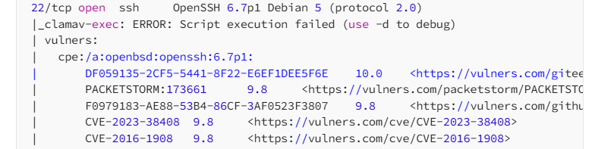
During nmap scan

- Non technical explain: This is like knocking on doors in an apartment building and listening closely. If you knock and someone says "Who is it?" immediately, you know the room is occupied. If it stays completely silent for a long time, you assume it's empty. By measuring how long the "silence" lasts, an attacker can figure out exactly which apartments have people living in them without ever seeing inside.
- Mitigation
Update OpenSSH to version 8.0 or above
Implement fail2ban or equivalent to block IPs after 3 repeated failed auth attempts for 1min to stop bruptforce attack

9- Vulnerability Name: Sensitive Information Exposure via HTTP Location Header

- Severity: Medium
- Business Impact: Minor
- Exploitation Likelihood: Likely
- Analysis: During proxy analysis using Burp Suite, it was observed that the web application’s HTTP redirect responses (301/302) include Location headers that reveal internal directory paths. These paths were not intended for public disclosure. This vulnerability, classified as CWE-201, occurs when sensitive information is inserted into data sent out to the user. While it doesn't provide direct access, it significantly aids an attacker's reconnaissance phase by identifying hidden administrative or staging directories that would otherwise remain unknown.
- POC: The vulnerability was identified by capturing HTTP traffic during attempt or while navigating to a non-existent page. By inspecting the 302 Found response in Burp Suite's HTTP History, the Location header was found to contain an internal path:
Request: GET //sup3r_s3cr3t_fl4g.php HTTP/1.1
Response: HTTP/1.1 302 Found
Location: /wExYY2Cv.qu hidden path

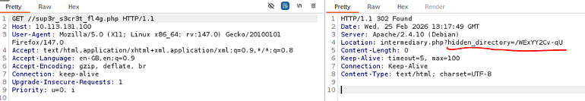
After we find a leaked path in css code and open the response in buirpsuit we find hidden directory

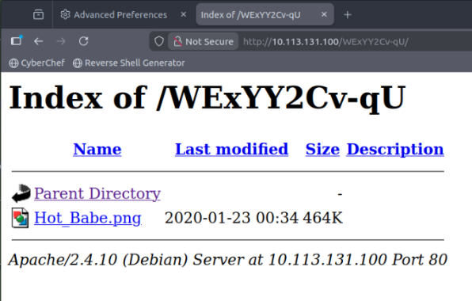
After we open it we find photo we used later to get more privilege

- Non technical explain: This is like asking a receptionist for directions to the restroom, and instead of just pointing the way, they accidentally hand you a map that shows the location of the CEO’s private office and the server room. Even though you don't have the keys to those rooms yet, you now know exactly where they are hidden in the building

- Mitigation
Audit all redirect responses ensure Location headers only reference intended public paths Configure the web server to use relative paths or sanitized paths in redirects Implement a WAF rule to strip or sanitize the Location header value before sending to clients
10- Vulnerability Name: Hidden Directory Exposure via CSS Source Code Review
- Severity: Low
- Business Impact: Minor
- Exploitation Likelihood: Unlikely
- Analysis: During a manual security review of the application's client-side assets, a non-public directory path was discovered embedded within a publicly accessible CSS file. This finding is classified as CWE-200: Exposure of Sensitive Information to an Unauthorized Actor. While the severity is low because it doesn't grant immediate access, disclosing internal directory structures significantly aids an attacker during the reconnaissance phase, making it easier to map the attack surface of the application
- POC: The vulnerability was confirmed by inspecting the source code of the site’s main CSS files (e.g., style.css or main.css). A comment or a background-image URL was found referencing a hidden directory: /* Technical Note: Assets moved to /dev_backup_v1/temp_images/ */ Alternatively, a path was found in a CSS rule: .background { background-image: url("/internal_assets_ignore/bg.png"); } This allowed the discovery of the /internal_assets_ignore/ directory, which was not linked anywhere else on the public site.

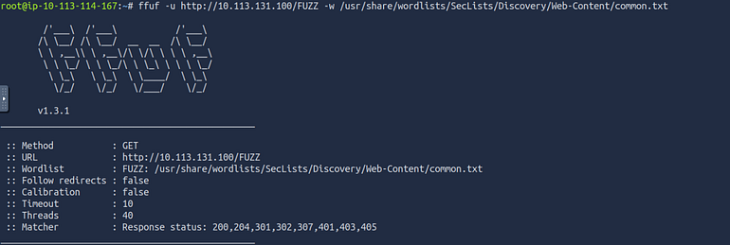
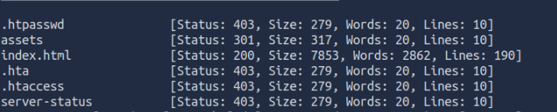
Fuzzing for hidden directories find assets directory

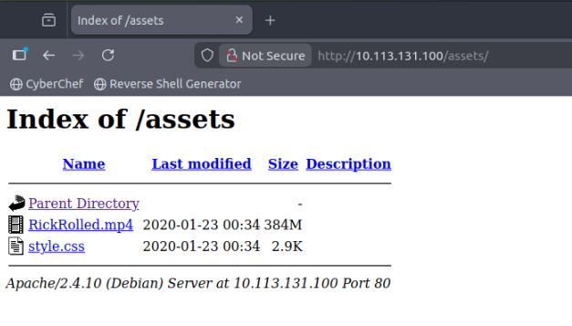
Find video and css styling code
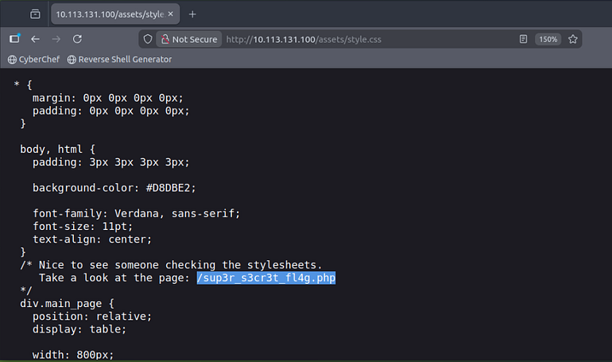
After source code review Hidden directory in css file

- Non technical explain: This is like a store leaving a note on the front window for the cleaning crew that says, "The spare key is under the mat at the back delivery door." Even though a regular customer wouldn't look for that note, anyone who takes the time to read the "fine print" on your building can find information about private areas they weren't supposed to know about.
- Mitigation
Remove all internal path references, comments, and debug information from production CSS, JS, and HTML files Implement a build pipeline that strips comments and minifies assets before deployment Perform periodic source code audits on all publicly served static files

11- Vulnerability Name: Sensitive Messages & Credentials Stored on System
- Severity: High
- Business Impact: Major
- Exploitation Likelihood: Likely
- Analysis: During the assessment, it was identified that administrative or IT staff stored sensitive information directly on the target machine in an insecure manner. This included plaintext credentials, internal notes, and staff communications accessible through the filesystem. A file named Eli's_Creds.txt containing SSH credentials (obfuscated using Brainfuck encoding) was found within an accessible FTP share. Additionally, upon SSH login, a hidden message from the root account to a user (Gwendoline) was displayed via the system MOTD (Message of the Day), indicating that administrators were using the system itself as a communication channel for sensitive information. This represents a serious operational security failure
• POC:

From this message we know that there is other user called Gwendoline

• Mitigation: Remove all credential files and internal notes from the system immediately Rotate all exposed credentials (assume full compromise)
• Non-technical explanation:
This is like employees writing passwords and secret instructions on sticky notes and leaving them inside the office where anyone who gets in—even briefly—can read them. Even if the note is written in a “coded” way, it’s still accessible, and anyone determined enough can figure it out and use it to break deeper into the system.

TOOLS USED
Tool | Description
Nmap | Port scanning, service fingerprinting, version detection across all in-scope hosts.
Burp Suite Community | Web application testing — proxy interception, HTTP history analysis, header inspection, redirect analysis.
ffuf | Fast web fuzzer used to discover hidden directories, endpoints, and parameters via wordlist brute-forcing.
Metasploit Framework | Exploitation of identified vulnerabilities; validation of CVE-2021-3156 (Baron Samedit).
exiftool | EXIF metadata extraction from images hosted on the target web server — led to FTP credential discovery.
OpenVAS | Automated vulnerability scanning to identify known CVEs across in-scope services.
Hydra / Medusa | Credential brute-forcing to validate password policy strength on SSH and FTP services.
searchsploit / ExploitDB | Research and identification of public exploits for discovered software versions.
Table A.1: Tools used during assessment

References
- https://cwe.mitre.org/data/definitions/312.html
- https://cwe.mitre.org/data/definitions/522.html
- https://owasp.org/Top10/A02_2021-Cryptographic_Failures/
- https://owasp.org/Top10/A05_2021-Security_Misconfiguration/

ENGAGEMENT INFORMATION Client Information
Field | Details
Client | TryHackMe
Primary Contact | Mohammed Mostafa (DEPI Instructor)
Engagement Type | Black-box Penetration Test
Authorized Approvers | TryHackMe, Mohammed Mostafa (DEPI Instructor)

Version Information
Version | Date | Description
2.0 | March 17, 2026 | final report delivered to client

Contact Information
Field | Details
Team Name | Elite Team
Team Leader | Marwan Nabil
Address | Mandarah, Alexandria, Egypt
Phone | 01272480891
Email | marwannabilconnect@gmail.com

Assessment Team
Name | Student ID
Marwan Nabil Ahmed Mohamed (Team Leader) | 21139703
Mostafa Ismail Mostafa Elhdad | 21067928
Ahmed Tamer Ahmed Nour Eldin Mostafa | 21052018
Abdelrahman Mohamed Sobhy | 21068769
Mustafa fathy Wahbi Mohamed | 21072555
Yousef Mahmoud Abdel Maqsud Hanoura | 21020214

